Access S3 bucket as Origin from Cloudfront edge location with Origin Access Identity to access S3 bucket

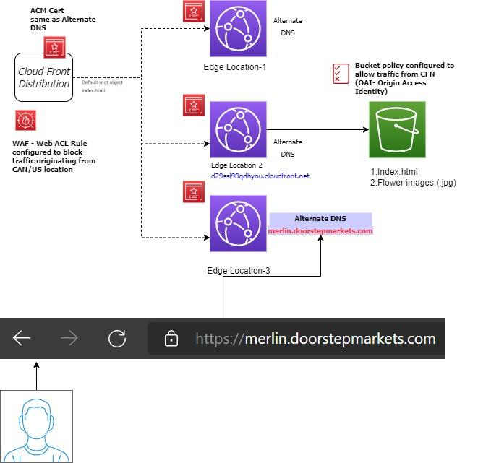

1. Created S3 bucket and stored index.html and Flower images as objects in that bucket
2. Created **cloudfront distribution (unit of configuration in AWS CDN)**

2.1 used S3 bucket as origin

2.2 Changed distribution setting to use all edge locations for best performance

2.2 created Web Application Firewall (WAF) web ACL rule to block traffic originating from certain country based on source IP address

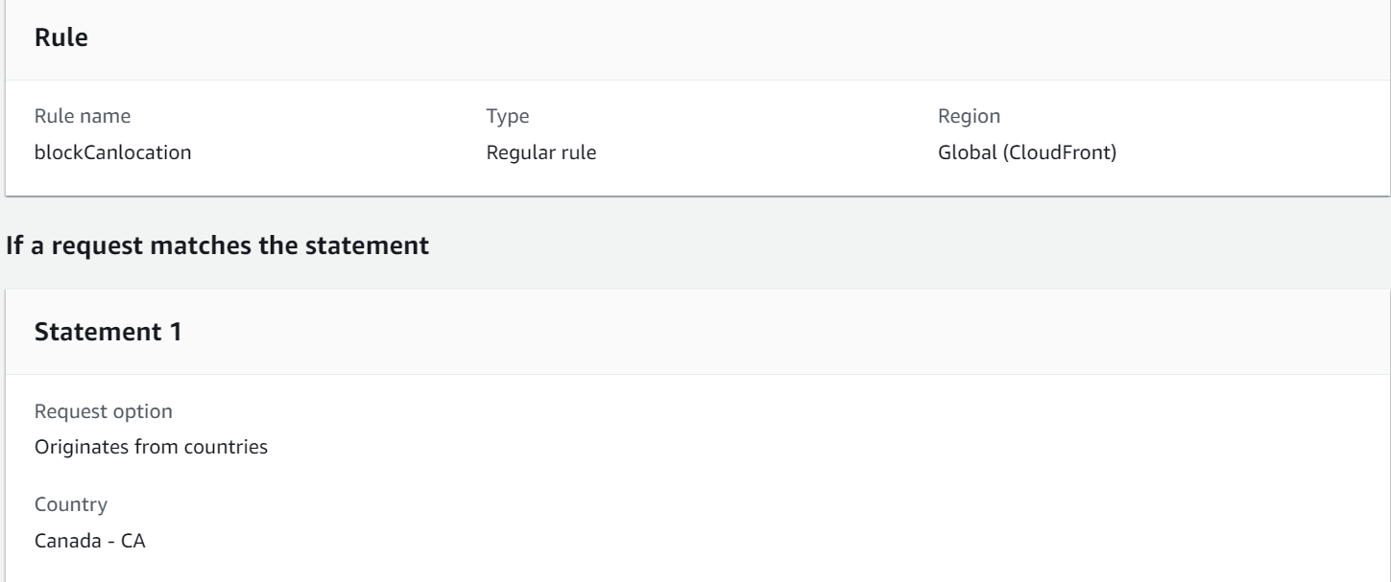

2.3 set alternate domain name **at distribution level** with custom SSL certificate(same name as alternate domain name) created from ACM service

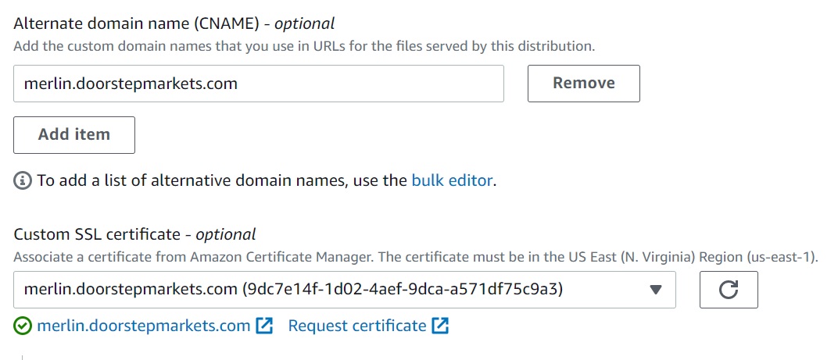

2.4 created Route53 Alias record with alternate DNS mapped with cloudfront distribution URL

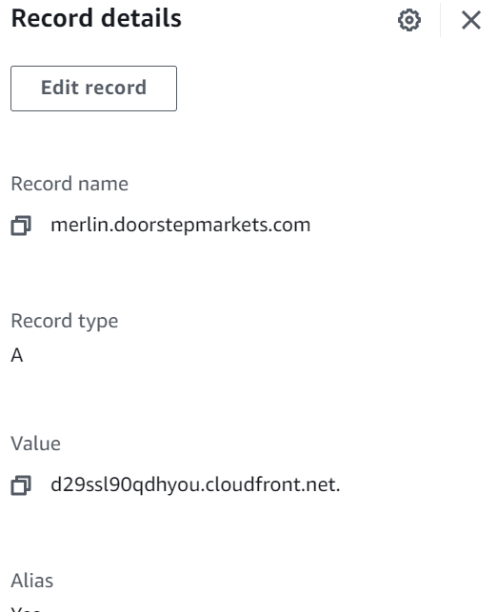

2.5 specified index.html as route object

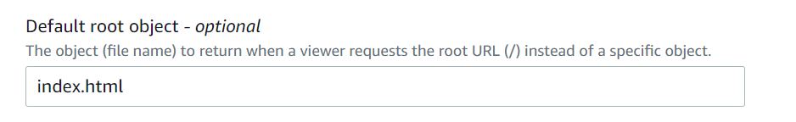

2.6 As part of **behavior configuration setting change**, made following changes to viewer protocol policy and Cashe policy, Origin request policy

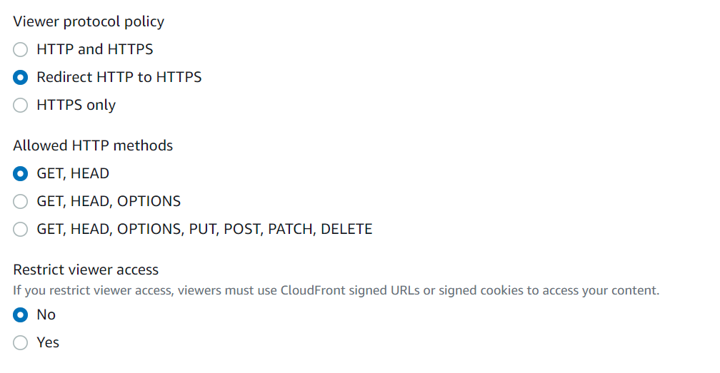

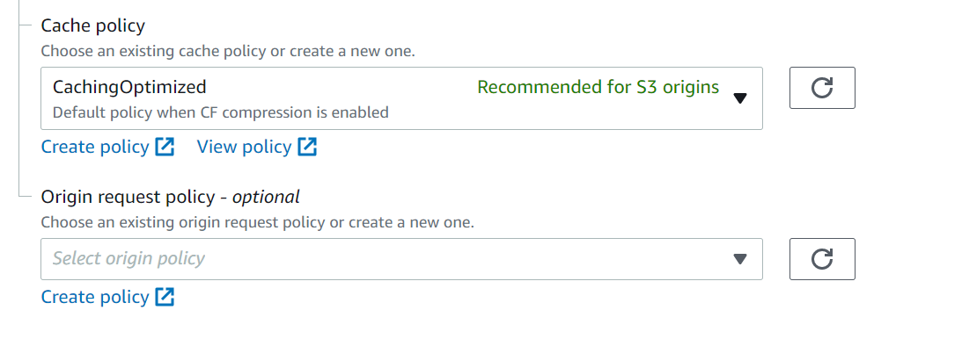

2.7 As part of Origin setting, made following changes to bucket access to use OAI and bucket policy is also updated to connect S3 from Origin Access Identity (OAI) as specified below,

